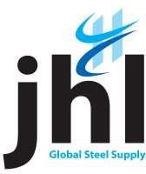
Modern Slavery Statement
At Jolliffe Hepburn Limited, we are committed to preventing modern slavery and human trafficking in our operations and supply chains. We recognise our responsibility to uphold human rights and ensure that our business practices do not contribute to any form of exploitation.

Our Commitment
We are dedicated to
- Ensuring fair labour practices and safe working conditions for all employees
- Conducting thorough due diligence on our suppliers to identify and mitigate risks of modern slavery
- Providing training and resources to our staff to recognise and address potential signs of modern slavery
- Collaborating with industry partners and stakeholders to promote ethical practices and transparency

Our Actions
To combat modern slavery, we have implemented the following measures
- Regular audits of our supply chains to ensure compliance with our ethical standards
- A whistleblowing policy that encourages employees to report any concerns related to modern slavery

Our Future Goals
We are committed to continuous improvement in our efforts to eradicate modern slavery. Our future goals include
- Expanding our supplier audits to cover more tiers of our supply chain
- Enhancing our training programs to include more comprehensive modules on modern slavery
- Increasing our engagement with stakeholders to drive collective action against modern slavery
Conclusion
Modern slavery has no place in our business or supply chains. We will continue to take proactive steps to ensure that our operations are free from exploitation and that we uphold the highest standards of ethical conduct.
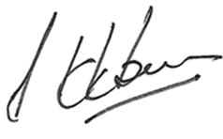

Julian Hepburn, Managing Director
Version 01, 15.07.2024

